

**

***Databases – ISAD253SL***

**Coursework**

**2020 – 2021**

Term: Term 1

Submission Deadline:

Coursework Type: Group Assignment (6 members)

Element of Assessment: C1 and P1

Module Leader: Naji Saravanabavan

E-mail: [rutsnasiketha@plymouth.ac.uk](mailto:rutsnasiketha@plymouth.ac.uk)

**Coursework**

A library service wants to create a database to store details of its libraries, books, and borrowers. Details include the following: A book has a unique ISBN number, a title and one or more authors. The library service may own several copies of a given book, each of which is located in one of the service’s libraries. A given library contains many books, and in order to distinguish different copies of the same book a library assigns a different copy-number to each of its copies of a given book; the price that was paid for each copy is also recorded. Every library has a unique name and is either a main library or a branch library. A main library may have zero or more branch libraries and every branch library is a branch of exactly one main library. A borrower has a name and a unique ID code. A borrower can have many books on loan, but each copy of a book can only be on loan to one borrower. A borrower could borrow the same book on several occasions, but it is assumed that each such loan will take place on a different date.

The main operation and the details are included here & the developers can suggest some new options and services for the above system. To implement the new and advanced options you can assume any database related structures and constrains.

**Tasks**

The aim of this coursework is to analyse the above case study to design and develop a database in Microsoft SQL Server including high data integrity and data validation to facilitate the following.

1. Allow the administrative staff to enter and maintain details about all the project activities. Your application should include appropriate **data validation** mechanisms (constraints), **triggers** and **user defined functions**.
2. Allow authorized parties to view details to generate meaningful management reports to make strategic, long term and short-term managerial decisions. Your application should include appropriate **views** and **stored procedures** to retrieve operational data.

**Deliverables**

**Deliverable 1**

You should submit **a document** containing:

**Section 1:**

* A basic introduction to the scenario with the important facts you have identified and considered to your solution. (Do not copy and paste the given scenario as it is)
* An Entity Relationship (ER) or Extended Entity Relationship (EER) Diagram showing all of the entities, their attributes, relationships, cardinality ratio and the participation constraints. (Should include a sensibly resized diagram which clearly show all the elements)
* A list of any additional assumptions you have made which affect your solution.
* Relational Mapping (Have to clearly indicate the steps of relational mapping with all table attributes, primary keys and foreign keys)
* Data Normalization (Have to clearly indicate all the steps of up data normalization up to Third normalization form).
* Data Dictionary of each normalized table. (Should contain all the details about each table field)

**Section 2:**

* Microsoft SQL Server **Create Table** statements with related **Constraints** for each table to validate data. (Should include sensibly resized screenshots of all the table creation statements which clearly show all the SQL statements)
* Database Diagram of your solution. (Should include a sensibly resized diagram which clearly show all the elements)
* A set of relevant and sensibly sized screen shots showing all the tables in your application with some meaningful sample records. (Should insert more than 10 meaningful sample records to each table in your database).

**Section 3:**

* Microsoft SQL Server **Create Trigger** statements for the triggers that you have created. (Should create at least two triggers for your database and should provide sensibly resized screenshots of the SQL statements)
* Microsoft SQL Server **Create Function** statements for the user defined functions that you have created. (Should create at least two user defined functions for your database and should provide sensibly resized screenshots of the SQL statements)
* Microsoft SQL Server **Create View** statements for the database views that you have created. (Should create at least two database views for your database and should provide sensibly resized screenshots of the SQL statements)
* Microsoft SQL Server **Create Procedure** statements for the stored procedures that you have created. (Should create at least two stored procedures for your database and should provide sensibly resized screenshots of the SQL statements)

**Section 4:**

* A critical appraisal of your solution highlighting worthy features, together with any shortcomings and how they might be resolved.
* Comments on future implementation of your application. Note that you should include all the SQL queries you have created within your database including Data Definition Language (DDL) and Data Manipulation language (DML) for tables, triggers, views, stored procedures and user defined functions. You should provide sensibly resized screen shots to show all the SQL statements within the database that you have created.

**Deliverable 2**

A complete backup of your database (.bak) with a softcopy of the report (.docx or .pdf) and the presentation slide show (.pptx) archived as a ZIP file. Note that any part of your submission in an incorrect file format cannot be marked. Coursework may be submitted at any time ahead of the deadline time. Please note the University regulations concerning late submission of coursework. Please note that the late submissions of project deliverables will not be assessed.

**Deliverable 3**

You will be required to perform a 5-minute presentation of your solution followed by a 10-minute question and answer (viva) session.

Note that the database objects and applications may be accessed in your absence as part of the assessment process. You should ensure that your tables are populated with an adequate amount of sensible test data in advance of this session and it is particularly important that date and time-dependent data is applicable to the date and time of your solution.

The presentation and viva will be taken according to a schedule prepared by NSBM. Students will be informed about the schedule prior to the submission.

**Assessment**

The assignment assesses the Learning Outcomes of the module,

1. Write effective SQL statements for defining, manipulating and controlling data.
2. Design and implement a multi-user database application

**Assessment criteria**

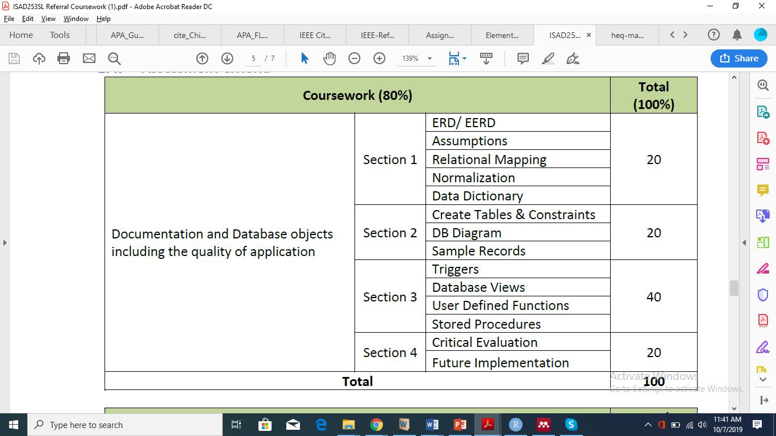

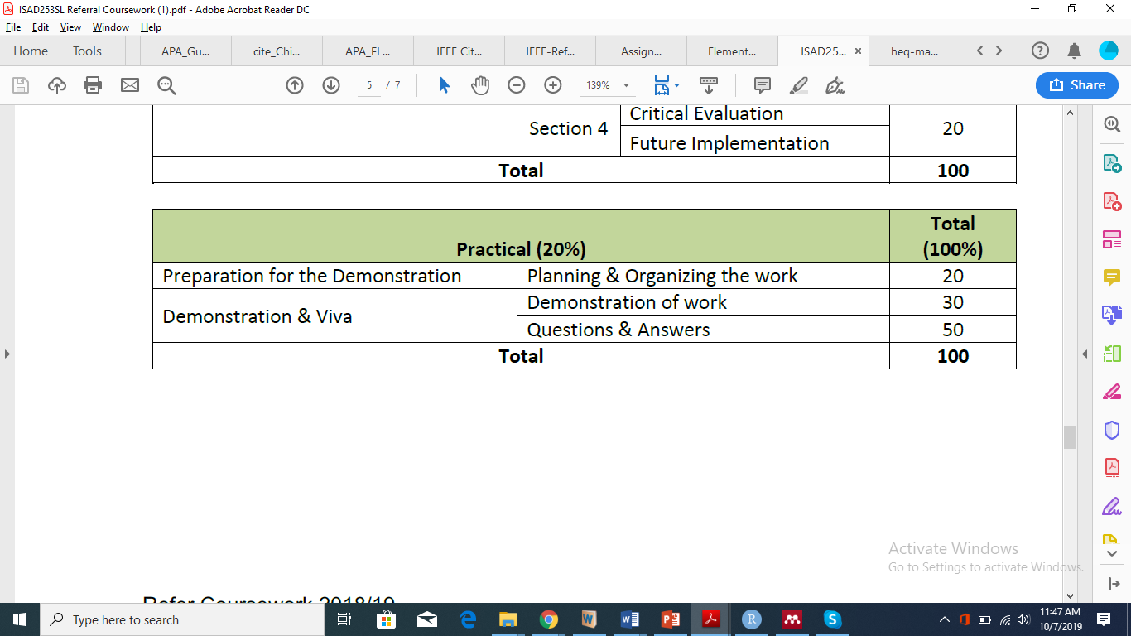

**Marks allocation and assessment criteria**

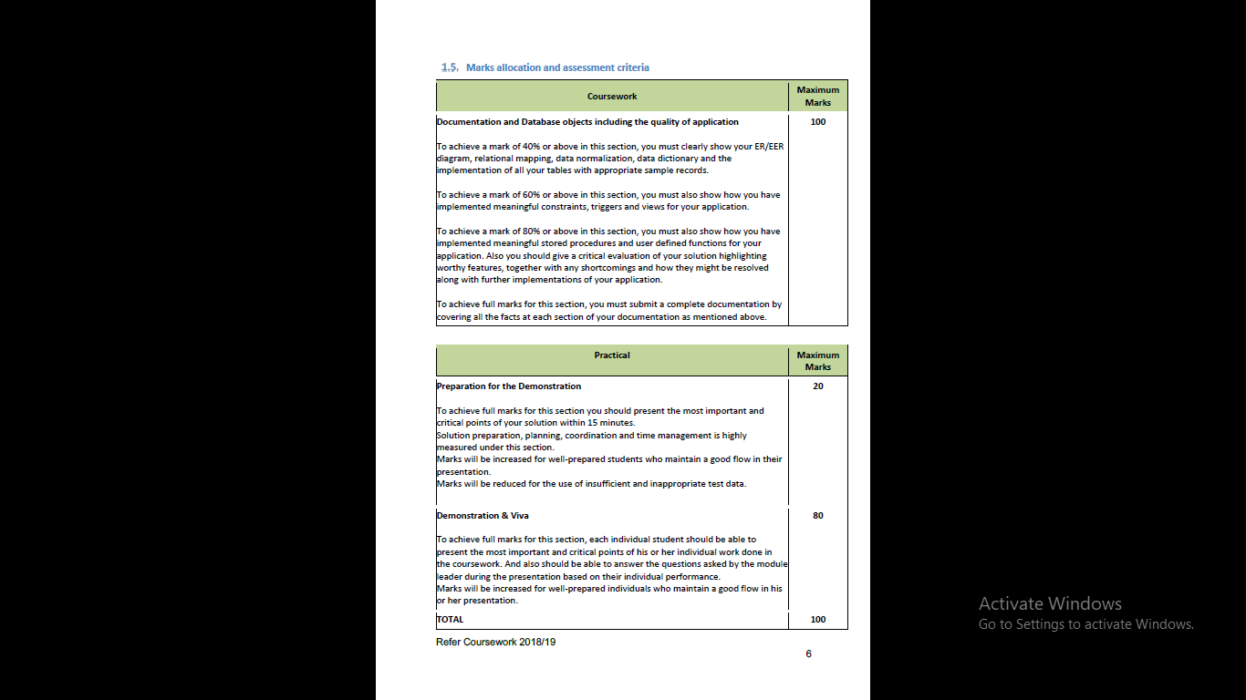



**Submission Type**

Moodle e-submission through Plymouth Digital Learning Environment (DLE) is compulsory for each module.

**Assignment Feedback:**

You will receive provisional mark and written feedback within 20 working days of the submission and presentation.

Notes:

* You must submit your coursework via the Digital Learning Environment portal. **Coursework must be submitted by the specified deadline.**
* You should give due consideration to your personal time management to ensure that coursework is submitted in plenty of time prior to the deadline.
* Coursework can be submitted at any time ahead of the deadline.
* Please note that work submitted late without valid extenuating circumstances will be penalized. Work submitted within 24 hours after the deadline will receive a mark, but it will be capped at the normal pass mark for that module. Work submitted more than 24 hours after the official deadline will receive an automatic mark of zero.
* The report that you present should be supported (where relevant) by appropriate evidence. Any such information that you present must be appropriately cited and referenced in your report - if you are unfamiliar with referencing style, then a Google search using the term 'Harvard referencing' will help to enlighten you. (Please refer the teaching and learning handbook for more details)
* Although you will be expected to make significant use of printed and online literature in researching and producing your materials, it is not acceptable for you to simply cut and paste material from other sources (small quotes are acceptable, but they must be clearly indicated as being quotes and the source must be referenced appropriately).

**Academic offences:**

(the following is a fragment of Section AST10.2 from <https://www.plymouth.ac.uk/uploads/production/document/path/8/8388/Section_D_Assessment.pdf>)

Academic offences occur when activity is undertaken which could confer an unfair advantage to any candidate(s) in assessment. The University recognises the following (including any attempt to carry out the actions described) as academic offences, regardless of intent:

a) Copying or paraphrasing of other people’s work or ideas into a submitted assessment without full acknowledgement (plagiarism).

b) Unauthorised collaboration of students (or others) in a piece of work (collusion).

c) Making false declarations in an attempt to obtain either modified assessment provisions or special consideration (e.g. of extenuating circumstances).

d) Persuading another member of the University or partner institution (student, staff, or other) to participate in any way in actions which would be in breach of these regulations.

e) Misrepresenting research outcomes and results.

f) Being party to any arrangement which would constitute a breach of these regulations.

g) The inclusion in a piece of assessed work (other than an examination or test) of material which is identical or substantially similar to material which has already been submitted for any other assessment within the University.

h) Any other activity which could confer an unfair advantage to any candidate(s).

For full details on the academic offences framework and procedures, consult Section AST10 from <https://www.plymouth.ac.uk/uploads/production/document/path/8/8388/Section_D_Assessment.pdf>